

BS-CS

Artificial Intelligence

6th Semester section ‘A’

Semester Project

Submitted To :
Mam.Amna Shakeel

Submitted By :
Junaid Niazi

22-CS-187

Hamza Mujeed

22-cs-087

Date:June 16, 2025.

Title: Dynamic Tourist Guide

Table of Contents
- Title Page
- Table of Contents
- Executive Summary
- Introduction
- Project Background
- Objective
- Scope
- System Requirements
- Hardware Requirements
- Software Requirements
- System Design
- Flowchart
- Implementation
- Technologies Used
- Code Structure
- Results and Discussion
- Screenshots
- Challenges
- Appendices
- Source Code

Executive Summary
The Dynamic Tourist Guide is an AI-based Python application that recommends tourist locations based on the user's preferences, budget, and current location. It uses clustering, heuristic-based distance calculation, and rule-based filtering to generate intelligent suggestions. The system enhances travel planning by providing optimized, personalized tourist spot recommendations within Islamabad using AI techniques.

Introduction

Project Background
Tourists often struggle to find suitable locations within a city that match their interests, travel budget, and proximity. This project addresses that challenge using intelligent agents and clustering algorithms.

Objective
- To build a system that:
- Recommends nearby tourist places based on interest and budget.
- Utilizes AI techniques like KMeans clustering, heuristics, and rule-based systems.

Scope
- Focused on locations in Islamabad.
- Allows extension to any city with updated datasets.
- Can be integrated with real-time APIs (e.g., Google Maps) in future.

- System Requirements

Hardware Requirements
Component | Minimum | Recommended
Processor | Core i3 | Core i5 or higher
RAM | 4 GB | 8 GB or higher
Storage | 500 MB | 1 GB+
OS | Windows 10/Linux/Mac | Windows 11/Linux/Mac

Software Requirements

Libraries :
- pandas – Data manipulation
- scikit-learn – KMeans clustering
- geopy – Geodesic distance calculation
- Algorithms :
- KMeans Clustering
- Heuristic Search (greedy nearest neighbor)
- Rule-Based Filtering

Development Tools
- IDE: Visual Studio Code
- Language: Python 3.8+

System Design

Flowchart
+-------------------------+
| User Input |
| (Lat, Lon, Budget, Type)|
+-----------+-------------+
|
v
+-------------------------------+
| Rule-Based Filtering |
| (Category & Cost Matching) |
+---------------+---------------+
|
v
+-------------------------+
| Clustering (KMeans) |
+-----------+-------------+
|
v
+-------------------------------+
| Heuristic Search (Nearest One)|
+-------------------------------+
|
v
+------------------------+
| Display Recommendations |
+------------------------+

Implementation

Technologies Used
Technology | Purpose
Python | Core language for implementation
scikit-learn | Clustering (KMeans)
geopy | Distance calculation
pandas | DataFrame and filtering

Code Structure
- Data Initialization: Static dataset in a list format converted into a DataFrame.
- User Input: Captures latitude, longitude, preferences.
- Filtering: Rule-based filtering of locations by category and budget.
- Clustering: KMeans groups locations spatially.
- Heuristic Logic: Distance-based nearest recommendations.
- Output: Printed sorted list of recommended locations.

Results and Discussion
- Outputs(Screenshots)
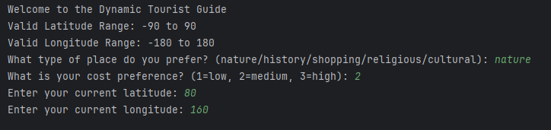
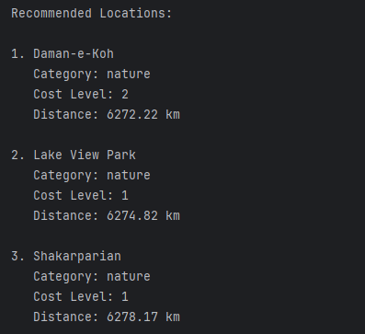

Challenges Faced
Challenge | Solution
Latitude/Longitude validation | Added range validation with error messages
Choosing optimal number of clusters | Tested with 2 clusters (city is small)
Avoiding empty results from filters | Graceful exit with message and user guidance
Lack of real-time data | Used static dataset, could be upgraded via API later

Appendices

Source Code
from sklearn.cluster import KMeans
from geopy.distance import geodesic
import pandas as pd
# Sample dataset: [Name, Latitude, Longitude, Category, Cost (1=low, 2=med, 3=high)]
locations = [
["Museum of History", 33.7294, 73.0931, "history", 2],
["Lake View Park", 33.7167, 73.1000, "nature", 1],
["Centaurus Mall", 33.7090, 73.0551, "shopping", 3],
["Faisal Mosque", 33.7294, 73.0380, "religious", 1],
["Saidpur Village", 33.7370, 73.0600, "cultural", 2],
["Daman-e-Koh", 33.7500, 73.0480, "nature", 2],
["Shakarparian", 33.6930, 73.0600, "nature", 1],
]
df = pd.DataFrame(locations, columns=["Name", "Lat", "Lon", "Category", "Cost"])
# --- USER INPUT ---
print("Welcome to the Dynamic Tourist Guide")
print("Valid Latitude Range: -90 to 90")
print("Valid Longitude Range: -180 to 180")
user_category = input("What type of place do you prefer? (nature/history/shopping/religious/cultural): ").strip().lower()
user_budget = int(input("What is your cost preference? (1=low, 2=medium, 3=high): "))
# Validate latitude and longitude input
try:
user_lat = float(input("Enter your current latitude: "))
user_lon = float(input("Enter your current longitude: "))
if not (-90 <= user_lat <= 90):
raise ValueError("Latitude must be between -90 and 90 degrees.")
if not (-180 <= user_lon <= 180):
raise ValueError("Longitude must be between -180 and 180 degrees.")
except ValueError as ve:
print(f"Input Error: {ve}")
exit()
# --- RULE-BASED FILTERING ---
filtered_df = df[(df["Category"] == user_category) & (df["Cost"] <= user_budget)]
if filtered_df.empty:
print("No locations match your preferences. Try changing category or cost level.")
exit()
# --- CLUSTERING ---
kmeans = KMeans(n_clusters=2, random_state=0)
filtered_df["Cluster"] = kmeans.fit_predict(filtered_df[["Lat", "Lon"]])
# --- HEURISTIC SEARCH (Nearest Location) ---
def get_travel_time(lat1, lon1, lat2, lon2):
return geodesic((lat1, lon1), (lat2, lon2)).km
filtered_df["Distance (km)"] = filtered_df.apply(
lambda row: get_travel_time(user_lat, user_lon, row["Lat"], row["Lon"]), axis=1)
# Sort by distance (heuristic: nearest first)
result_df = filtered_df.sort_values(by="Distance (km)").reset_index(drop=True)
# --- OUTPUT ---
print("\nRecommended Locations:")
for index, row in result_df.iterrows():
print(f"\n{index + 1}. {row['Name']}")
print(f" Category: {row['Category']}")
print(f" Cost Level: {row['Cost']}")
print(f" Distance: {row['Distance (km)']:.2f} km")

Conclusion :

The Dynamic Tourist Guide project successfully demonstrates how artificial intelligence can enhance personalized travel recommendations. By combining clustering, heuristics, and rule-based filtering, the system efficiently narrows down tourist spots based on user preferences and location. It provides a smart, location-aware experience for users seeking relevant destinations. The approach is scalable and adaptable to larger datasets and other cities. Overall, this project reflects practical AI application in real-world travel assistance scenarios.

